***BULLET POINT #3:***

***Here is the script that created the procedure:***

ET ANSI_NULLS ON

GO

SET QUOTED_IDENTIFIER ON

GO

-- =============================================

-- Author: Neil

-- Create date: 08/29/2016

-- Description: Update price

-- =============================================

CREATE PROCEDURE updateprice

-- Add the parameters for the stored procedure here

@INVNUM int = 0,

@NEWPRICE decimal (10,2) = 0.00

AS

BEGIN

-- SET NOCOUNT ON added to prevent extra result sets from

-- interfering with SELECT statements.

SET NOCOUNT ON;

-- Insert statements for procedure here

UPDATE PriceHistory

SET InventoryPrice = @NEWPRICE

WHERE InventoryNum = @INVNUM

END

GO

***Here is the procedure:***

EXEC [dbo].[UPDATEPRICE] @INVNUM=10001, @NEWPRICE=62.95;

***And, the results:***

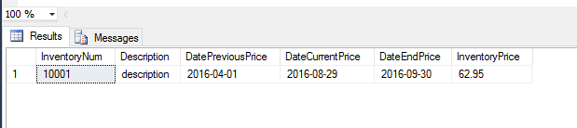

***BULLET POINT #4:***

***Here is the script:***

UPDATE PriceHistory

SET DateCurrentPrice = GETDATE()

INSERT INTO PriceHistory

VALUES ('10001', 'description', GETDATE(), GETDATE() + 1,NULL,23.95)

;

